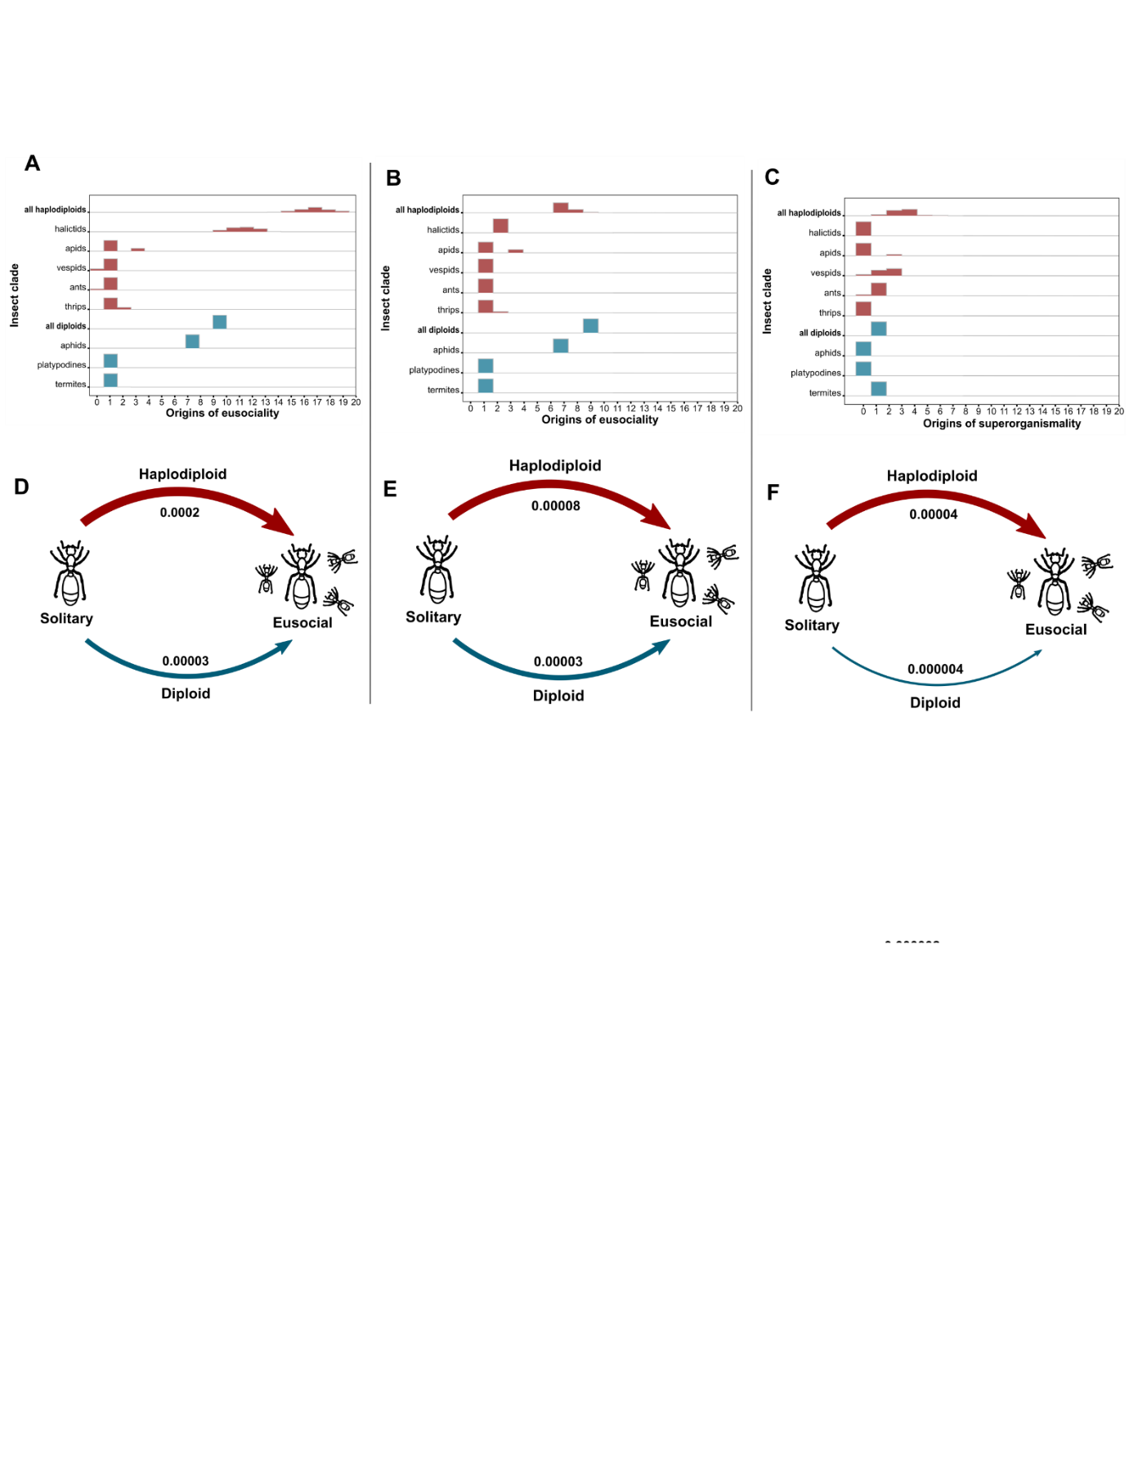

Fig. S2. The relative number of estimated origins of eusociality in haplodiploids versus diploids depends on the definition of eusociality and the phylogeny used, but the estimated rate of transition from solitary to eusocial life is consistently much higher in haplodiploid insects. (a-c) Estimated number of independent origins of eusociality in haplodiploid (red) and diploid (blue) lineages using (a) the conventional definition of eusociality and strict definition of haplodiploidy (i.e. arrhenotoky) on the full phylogeny; (b) the conventional definition of eusociality and strict definition of haplodiploidy in the pruned phylogeny where the estimated number of eusociality origins in the halictid bees was forced to two; (c) the superorganismal definition of eusociality and strict definition of haplodiploidy on the full phylogeny. (d-f) Estimated rate of transitions from solitary to eusocial in haplodiploids (red) and diploids (blue) using (d) the conventional definition of eusociality and strict definition of haplodiploidy on the full phylogeny; (e) the conventional definition of eusociality and strict definition of haplodiploidy in the pruned phylogeny where the estimated number of eusociality origins in the halictid bees was forced to two; (f) the superorganismal definition of eusociality and strict definition of haplodiploidy on the full phylogeny. These analyses were run using Chester’s 2020 phylogeny

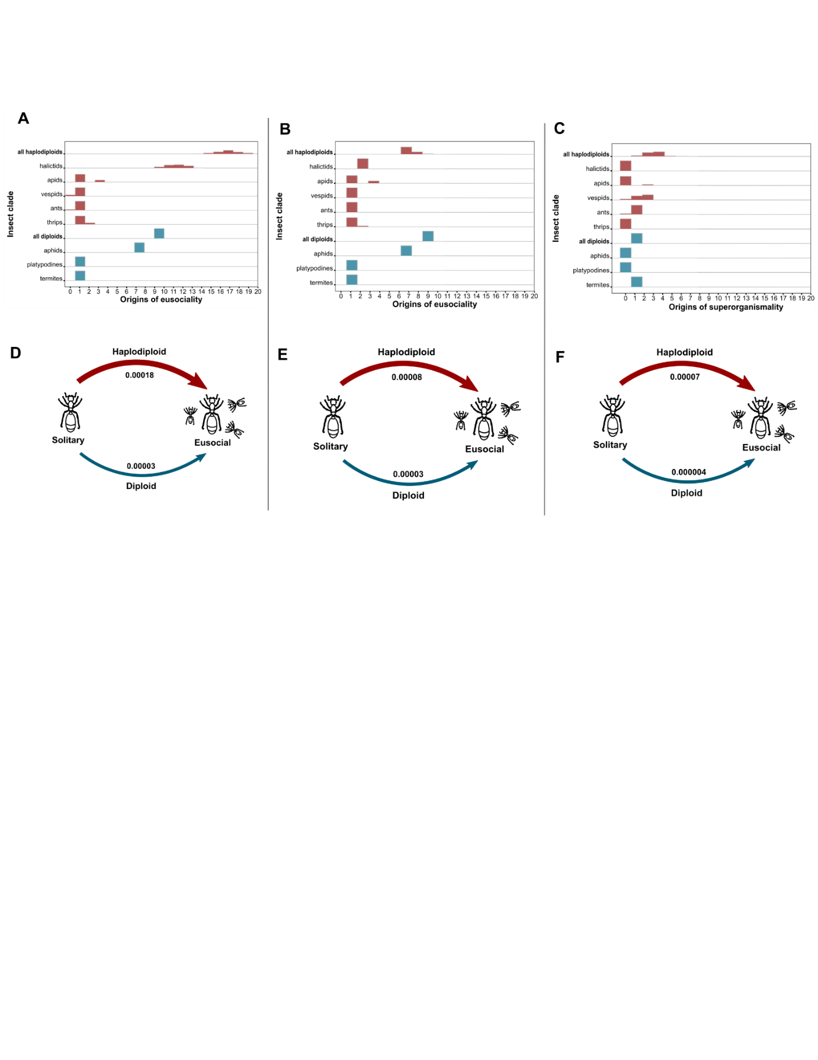
Fig. S3. The relative number of estimated origins of eusociality in haplodiploids versus diploids depends on the definition of eusociality and the phylogeny used, but the estimated rate of transition from solitary to eusocial life is consistently much higher in haplodiploid insects. (a-c) Estimated number of independent origins of eusociality in haplodiploid (red) and diploid (blue) lineages using (a) the “conventional” definition of eusociality and “broader” definition of haplodiploidy on the full phylogeny; (b) the “conventional” definition of eusociality and “broader” definition of haplodiploidy on the pruned phylogeny where the estimated number of eusociality origins in the halictid bees were forced to two; (c) the “superorganismal” definition of eusociality and “stricter” definition of haplodiploidy on the pruned phylogeny where the estimated number of eusociality origins in the halictid bees were forced to two. (d-f) Estimated rate of transitions from solitary to eusocial in haplodiploids (red) and diploids (blue) using (d) the “conventional” definition of eusociality and “broader” definition of haplodiploidy on the full phylogeny; (e) the “conventional” definition of eusociality and “broader” definition of haplodiploidy on the pruned phylogeny where the estimated number of eusociality origins in the halictid bees were forced to two; (f) the “superorganismal” definition of eusociality and “strict” definition of haplodiploidy on the pruned phylogeny where the estimated number of eusociality origins in the halictid bees were forced to two. These analyses were run using Chester’s 2020 phylogeny

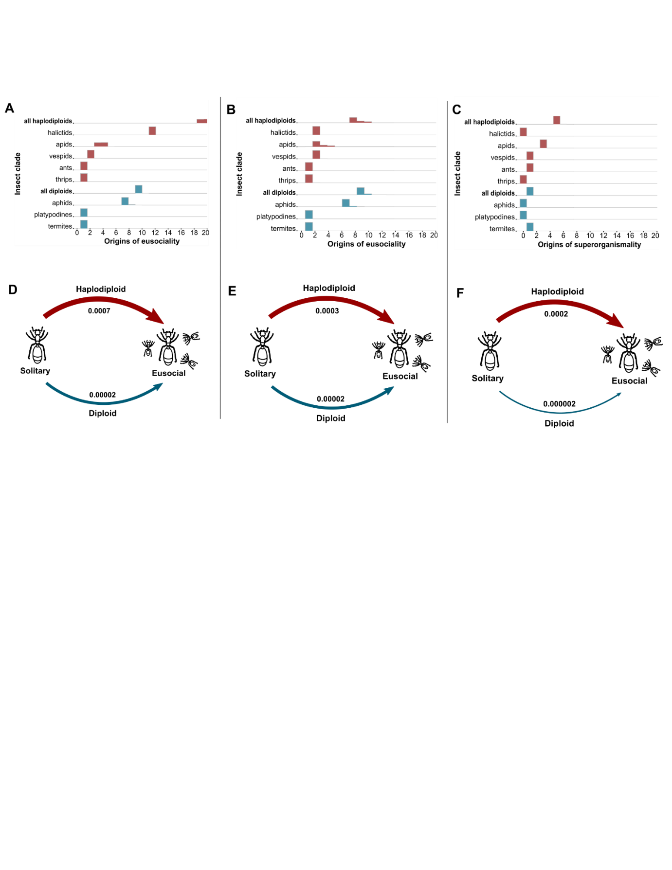
Fig. S4. The relative number of estimated origins of eusociality in haplodiploids versus diploids depends on the definition of eusociality and the phylogeny used, but the estimated rate of transition from solitary to eusocial life is consistently much higher in haplodiploid insects. (a-c) Estimated number of independent origins of eusociality in haplodiploid (red) and diploid (blue) lineages using (a) the conventional definition of eusociality and strict definition of haplodiploidy (i.e. arrhenotoky) on the full phylogeny; (b) the conventional definition of eusociality and strict definition of haplodiploidy in the pruned phylogeny where the estimated number of eusociality origins in the halictid bees were forced to two; (c) the superorganismal definition of eusociality and strict definition of haplodiploidy on the full phylogeny. (d-f) Estimated rate of transitions from solitary to eusocial in haplodiploids (red) and diploids (blue) using (d) the conventional definition of eusociality and strict definition of haplodiploidy on the full phylogeny; (e) the conventional definition of eusociality and strict definition of haplodiploidy in the pruned phylogeny where the estimated number of eusociality origins in the halictid bees were forced to two; (f) the superorganismal definition of eusociality and strict definition of haplodiploidy on the full phylogeny. These analyses were run using Chester’s 2017 phylogeny

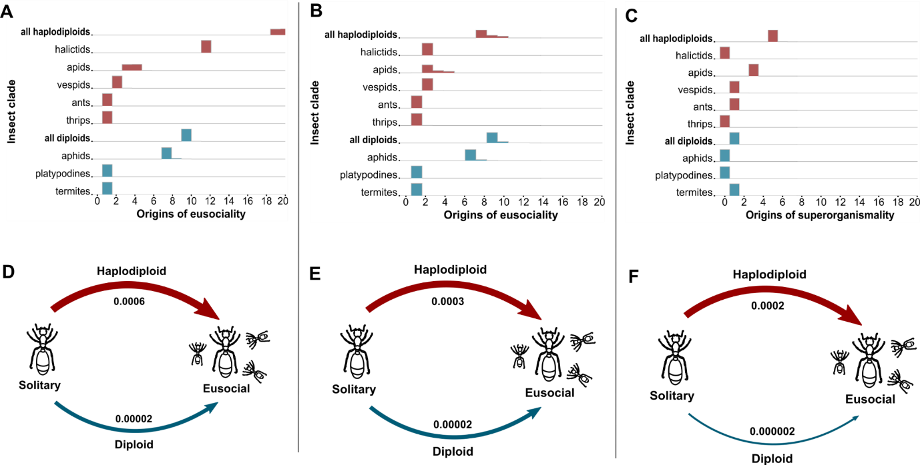
Fig. S5. The relative number of estimated origins of eusociality in haplodiploids versus diploids depends on the definition of eusociality and the phylogeny used, but the estimated rate of transition from solitary to eusocial life is consistently much higher in haplodiploid insects. (a-c) Estimated number of independent origins of eusociality in haplodiploid (red) and diploid (blue) lineages using (a) the “conventional” definition of eusociality and “broader” definition of haplodiploidy on the full phylogeny; (b) the “conventional” definition of eusociality and “broader” definition of haplodiploidy on the pruned phylogeny where the estimated number of eusociality origins in the halictid bees were forced to two; (c) the “superorganismal” definition of eusociality and “stricter” definition of haplodiploidy on the pruned phylogeny where the estimated number of eusociality origins in the halictid bees were forced to two. (d-f) Estimated rate of transitions from solitary to eusocial in haplodiploids (red) and diploids (blue) using (d) the “conventional” definition of eusociality and “broader” definition of haplodiploidy on the full phylogeny; (e) the “conventional” definition of eusociality and “broader” definition of haplodiploidy on the pruned phylogeny where the estimated number of eusociality origins in the halictid bees were forced to two; (f) the “superorganismal” definition of eusociality and “strict” definition of haplodiploidy on the pruned phylogeny where the estimated number of eusociality origins in the halictid bees were forced to two. These analyses were run using Chester’s 2017 phylogeny

